Name: **ZOHAIB HASSAN SOOMRO**

RollNo#: **19SW42**

Subject: **DSA**

Lab#3 Tasks

* **Task#1:**

Write a Java Code an Array of length 100 and fill it with Random int Values for testing purpose.

import java.util.Random;

public class Task1_RandomIntValues {

public static void main(String[] args) {

int array[] = new int[100];

for (int i = 0; i < array.length; i++)

array[i] = new Random().nextInt(array.length);

int line = 0;

System.***out***.println("Printing Array Values: ");

for (int i : array) {

System.***out***.print(i + " ");

line++;

if (line % 20 == 0)

System.***out***.println();

}

}

}

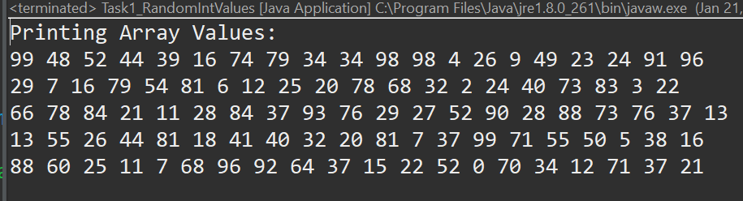

* **Task#2:**

Write a Java program to check if two arrays are equal.

import java.util.Arrays;

public class Task2_EqualArrays {

public static void main(String[] args) {

int array1[]= {2,5,4,7,8};

int array2[]= {2,5,1,7,8};

if (Arrays.*equals*(array1, array2))

System.***out***.println("Arrays are equal.");

else

System.***out***.println("Arrays are not equal!");

}

}



* **Task#3:**

Use all of the array method discussed above in your java code but array should not be of type integer.

import java.util.Arrays;

public class Task3_NotIntegerArray {

public static void main(String[] args) {

String array1[]= {"19sw42","19sw43","19sw44","19sw45"};

String array2[]= {"19sw42","19sw43","19sw46","19sw45"};

if (Arrays.*equals*(array1, array2))

System.***out***.println("Arrays are equal.");

else

System.***out***.println("Arrays are not equal!");

}

}

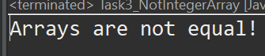

* **Task#4:**

Write a method in java with float as its return type that takes array as input and return average as output.

public class Task4_Average {

public static float average(int[] array) {

if(array.length==0) return -1;

float average, sum = 0;

for (int i = 0; i < array.length; i++)

sum += array[i];

average = sum / array.length;

return average;

}

public static void main(String[] args) {

int array[]= new int[100];

for (int i = 0; i < array.length; i++)

array[i]=i+1;

System.***out***.println("Average of first 100 numbers is "+*average*(array));

}

}

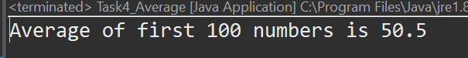

* **Task#5:**

Write a method in Java program to find 2nd largest element in an array. Method should take array as input and return index.

public class Task5_2ndLargestNum {

public static int secondLargest(int[] array) {

if (array.length == 0)

return -1;

int index = 0, newIndex=0;

ArrayList list = new ArrayList();

for (int i = 0; i < array.length; i++)

list.add(array[i]);

newIndex = list.indexOf(Collections.*max*(list));

list.remove(newIndex);

index = list.indexOf(Collections.*max*(list));

if (index >= newIndex)

return index + 1;

return index;

}

public static void main(String[] args) {

int array[] = { 2, 4, 1, 17, 6, 12 };

System.***out***.println("2nd Largest element in array is at index " + *secondLargest*(array));

}

}

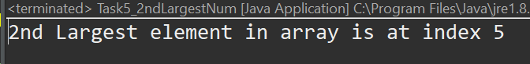

* **Task#6:**

Write a java program to sort an array (Two dimensional array).

import java.util.Arrays;

public class Task6_Sort2DArray {

public static void sort2D(int[][] array) {

if (array.length == 0) return;

int length = array.length;

for (int i = 0; i < length; i++)

Arrays.*sort*(array[i]);

int newArray[] = new int[length * array[0].length];

for (int i = 0; i < length; i++)

System.*arraycopy*(array[i], 0, newArray, i * array[i].length, array[i].length);

Arrays.*sort*(newArray);

for (int i = 0; i < length; i++)

for (int j = 0; j < array[i].length; j++)

array[i][j] = newArray[j + (array[i].length * i)];

}

public static void main(String[] args) {

int[][] array = { { 5, 3, 1 }, { 4, 2, 6 }, { 11, 0, 34 } };

System.***out***.println("2D Array before sorting: ");

System.***out***.println(Arrays.*toString*(array[0]) + "\n" + Arrays.*toString*(array[1])+ "\n"+Arrays.*toString*(array[2]));

*sort2D*(array);

System.***out***.println("2DArray after sorting: ");

System.***out***.println(Arrays.*toString*(array[0]) + "\n" + Arrays.*toString*(array[1])+ "\n"+Arrays.*toString*(array[2]));

}

}

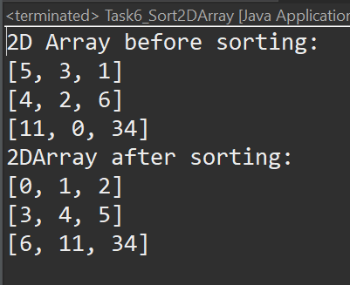

* **Task#7:**

Write a java program to remove duplicate elements of a given array and return the new length of the array.

Sample array: [20,20,30,40,50,50,50]

Output:

New array= 20,30,40,50

Length = 4

public class Task7_RemoveDuplicate {

public static int[] removeDuplicate(int[] array) {

if (array.length == 0)

return array;

int newLength = array.length;

for (int i = 0; i < newLength - 1; i++)

for (int j = i + 1; j < newLength; j++) {

if (array[j] == array[i]) {

for (int k = j; k < newLength - 1; k++)

array[k] = array[k + 1];

int newArray[] = array;

array = new int[newLength - 1];

System.*arraycopy*(newArray, 0, array, 0, array.length);

newLength = array.length;

j--;

}

}

return array;

}

public static void main(String[] args) {

int[] array = { 20, 20, 30, 40, 50, 50, 50, 40, 40 };

System.***out***.println("Old Array:");

System.***out***.println(Arrays.*toString*(array));

array = *removeDuplicate*(array);

System.***out***.println("\nnew Array:");

System.***out***.println(Arrays.*toString*(array));

System.***out***.println("\nNew Length= " + array.length);

}

}